Community Solutions
The Model
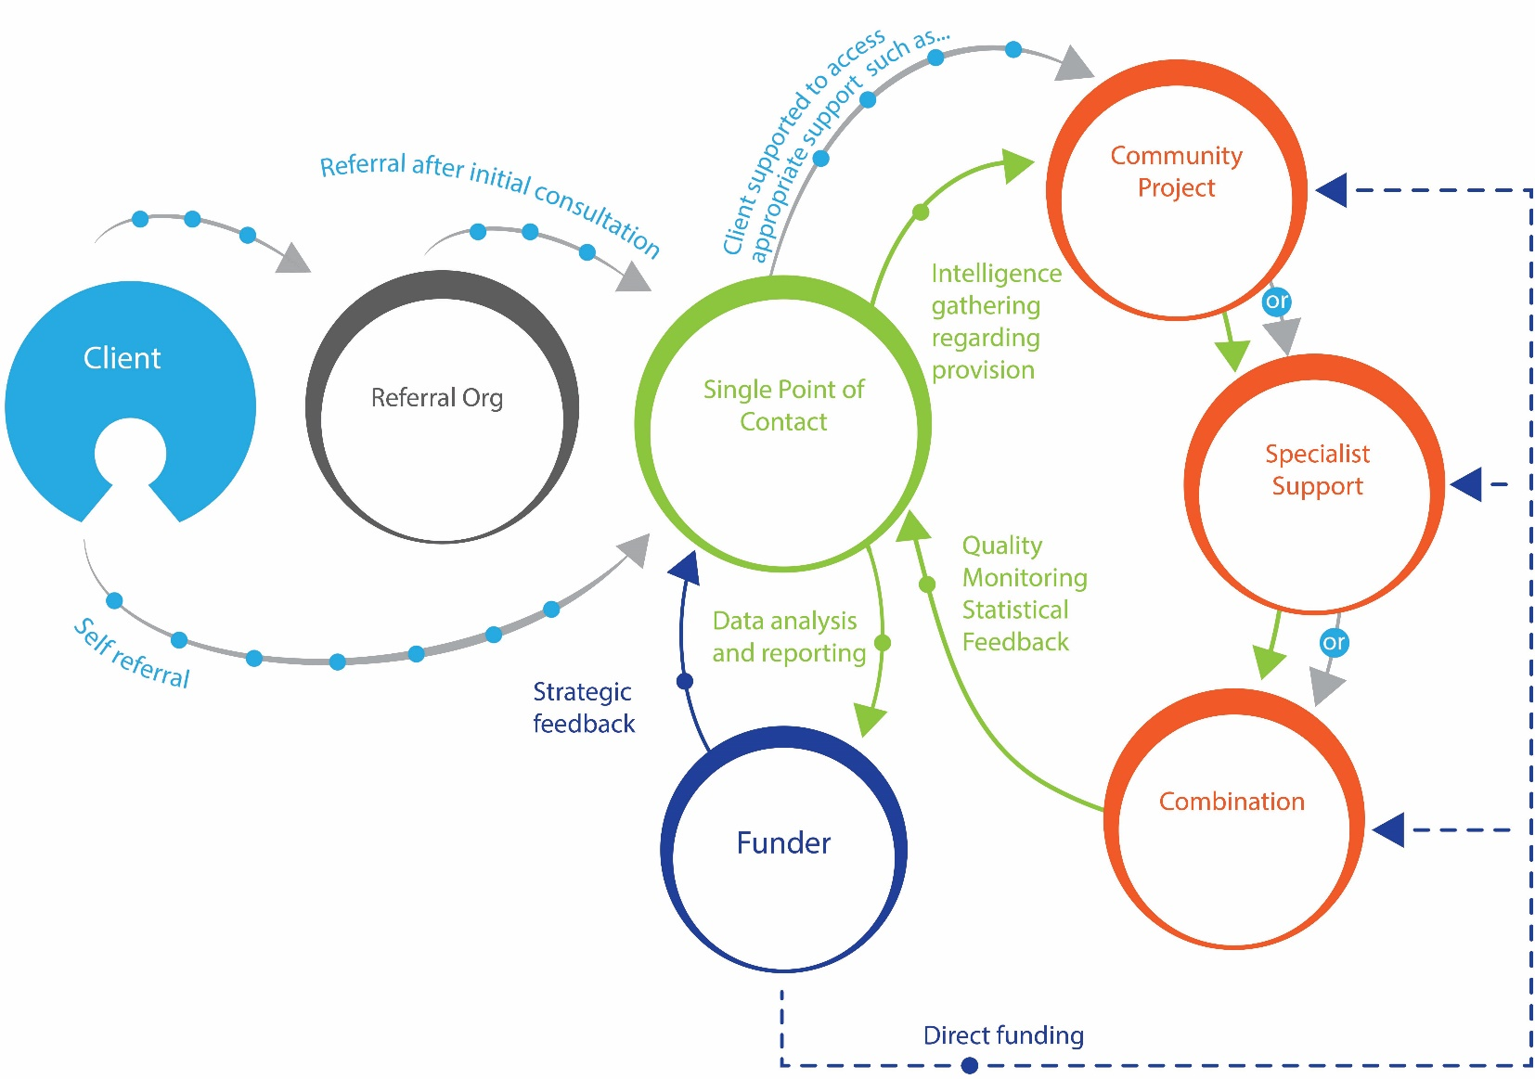

A way in which people can be referred, linked and supported to find whole person solutions that meet their social, emotional or practical needs and improve their health and wellbeing. This can happen through early intervention, prevention or supporting recognised pathways often using services provided by the voluntary and community sector.

The success of the model is dependent on many factors listed below – Values and Critical success Factors. The model has interdependent relationships that rely on the critical success factors and values all working together – there are many models of social prescribing, contract management and community solutions that seem similar but do not hold to all of these principles.
Many models will emerge as different localities respond to local need differently. A spectrum of approaches is to be welcomed following these core principles.

The Values
- Community Led – led and owned by the community it aims to serve – including honouring individuals, groups, and communities for the realities they face.
- People first – asset based enablement culture and approach.
- Partnership - collaborative approach.
- Local solutions - Local connectors, harnessing local action (structured or not).
- Transparency – discussions and decisions should be shared openly.

The Critical Success Factors
- Communication – Excellent communication channels across the whole system.
- Clarity - Include clear messages from partners, funders and referral organisations to the community (and each other) about purpose of the system the ongoing importance of the programme/process through commitment to delivering the agreed outcomes of any system.
- High Skill Level - the link worker/navigator/champion at the Single Point of Contact organisation work very proactively (e.g. going out and about and engaging people informally, becoming the ‘go-to’ person in the community) and have sufficient skills and experience to effectively work with the community and potential funders.
- Infrastructure Support – to support strategic development and coordination of the service and support staff and volunteers involved.
- Evolving - recognising that if it can't grow and develop it can't respond too differing/emerging priorities, or take advantage of change.
- Funding – recognition that this work does not simply exist without funding – this may be minimal and blended but services are becoming saturated (both statutory and voluntary sector)

