October 2020

Dear Safe Places organisation
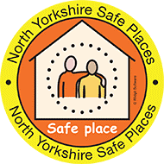
I am writing to you as the co-chair of the North Yorkshire Learning Disability Partnership Board. We are self-advocates, who speak up about issues which are important to us.
I am also the Safe Places representative for the Partnership Board. I joined the Safe Places scheme in 2013 and it is free to join.
The Safe Places scheme is important to me because I travel all over the place and sometimes I go alone.
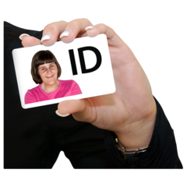
I often get panic attacks. It is comforting to know that I can go to a Safe Place and staff will help.
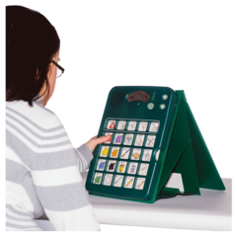
People who join the Safe Places scheme get a card to show to the staff working at a Safe Place. It has emergency contact details on.
The card also has images on it so if people are having trouble speaking they can point to the images so that staff know why they have come in.
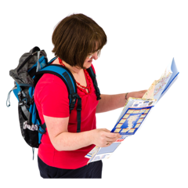
For example if I am lost but I can’t talk because I am having a panic attack I can point to the picture of a lost person and get help from the staff.
We would like to ask you to speak to your team about Safe Places and make sure they know what to do if someone needs help.
We have written some Top Tips for teams so people know what to do. A copy is attached for you.
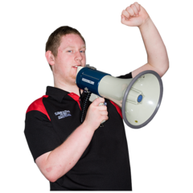
A lot of people still don’t know about the Safe Places scheme in North Yorkshire. We are going to let more people in the community know about Safe Places and how to get help if they need it.
We also want to get more businesses to be a Safe Place. If you would like to know more you can call Lesley Dale at North Yorkshire County Council.
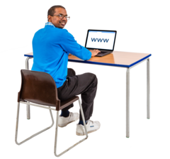
Lesley’s telephone number is 01609 533487 or you can email lesley.dale@northyorks.gov.uk. You can also look on the Safe Places North Yorkshire website: https://www.northyorks.gov.uk/safe-places
Thank you for your time.
Yours faithfully
Mark Hamblin
Co-chair, North Yorkshire Learning Disability Partnership Board

