May 2020
Dear friends
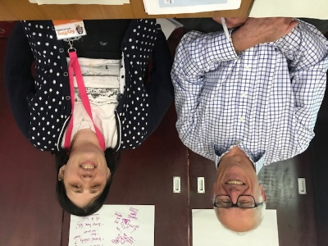 | This is a letter from Rebecca and Jim. We are the co-chairs of the Scarborough, Whitby and Ryedale Local Area Group.  We hope you are all OK during the lockdown. It is a very strange time for everyone.
 | Sadly we have to cancel the meeting in Malton in June because of Coronavirus.
 | Even though there is no meeting, our work will carry on. This letter has information about how we are staying in touch and keeping our work going.
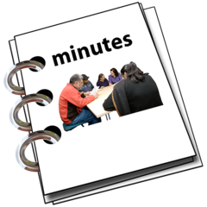 | Our last meeting was in Scarborough in February. The minutes are attached to this letter.  We talked about being a co-chair and about travel.
We have decided not to have the election for the new co-chairs in June.
We want everybody to be able to have a say and vote. We hope we can do this in September.
 | Jess from KeyRing has been in contact with self-advocates to make sure everyone is OK.
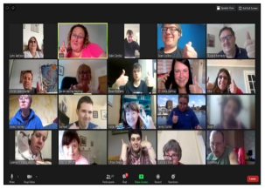 | Even though we can’t meet in person there have been lots of phone calls, emails and even sending letters in the post.  KeyRing have also helped self-advocates to do fun trivia parties on Zoom.  It is nice to see people’s faces!
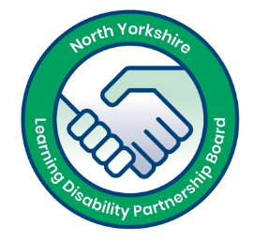  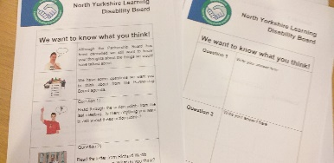 | The Partnership Board meeting in March was also cancelled because of coronavirus.  KeyRing sent self-advocates some questions about the Partnership Board work and talked on the phone. People had great ideas.  This will also help us keep our work going until we meet again.
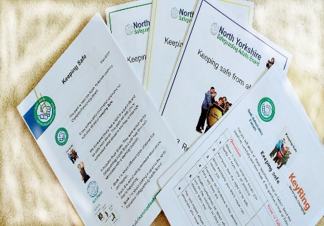 | We have been sending Keeping Safe Activity Packs to self-advocates. These include our new easy read Keeping Safe guides and some puzzles and questions to help people think about safety.  Services can get copies for people here: safeguardingadults.co.uk/keeping-safe/easy-read-guides/ or ask Jamie Bannister.
Our next Local Area Group meeting is planned to be in Scarborough in September.
We do not know if our September meeting will happen. We will listen to the Government and follow advice so that everyone can stay safe.
We are sorry that there have been so many changes to our plans. We are sad about this too.
If you have any questions please contact:
- Jess at KeyRing at Jessica.Finch@keyring.org
- Jamie from North Yorkshire County Council at jamie.bannister@northyorks.gov.uk

Take care and stay safe!
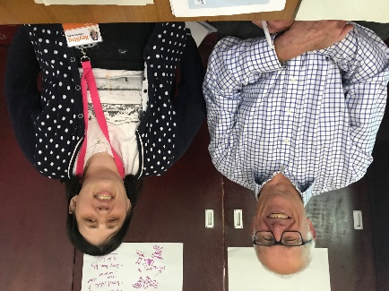
Rebecca and Jim
Co-Chairs, Scarborough, Whitby and Ryedale Local Area Group

